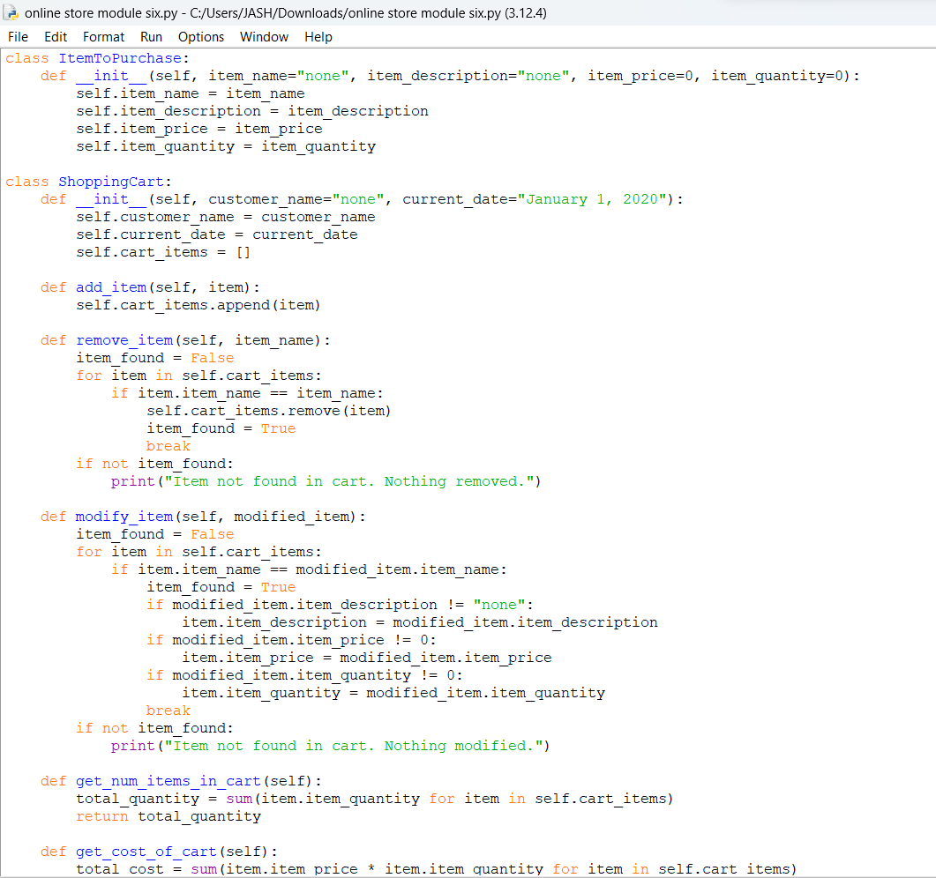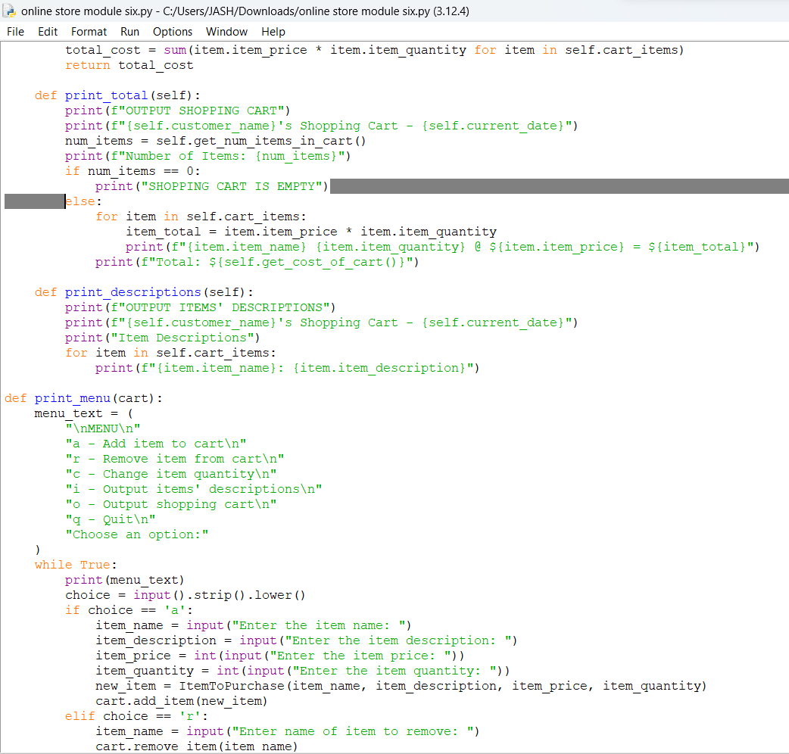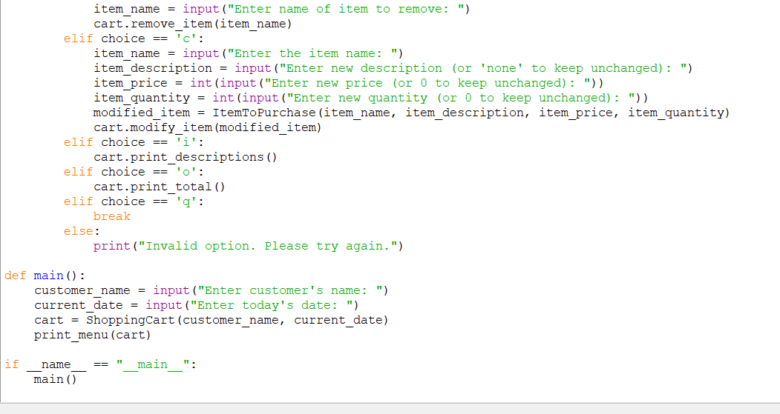

Python 3.12.4 (tags/v3.12.4:8e8a4ba, Jun 6 2024, 19:30:16) [MSC v.1940 64 bit (AMD64)] on win32

Type "help", "copyright", "credits" or "license()" for more information.

class ItemToPurchase:

def __init__(self, item_name="none", item_description="none", item_price=0, item_quantity=0):

self.item_name = item_name

self.item_description = item_description

self.item_price = item_price

self.item_quantity = item_quantity

class ShoppingCart:

def __init__(self, customer_name="none", current_date="January 1, 2020"):

self.customer_name = customer_name

self.current_date = current_date

self.cart_items = []

def add_item(self, item):

self.cart_items.append(item)

def remove_item(self, item_name):

item_found = False

for item in self.cart_items:

if item.item_name == item_name:

self.cart_items.remove(item)

item_found = True

break

if not item_found:

print("Item not found in cart. Nothing removed.")

def modify_item(self, modified_item):

item_found = False

for item in self.cart_items:

if item.item_name == modified_item.item_name:

item_found = True

if modified_item.item_description != "none":

item.item_description = modified_item.item_description

if modified_item.item_price != 0:

item.item_price = modified_item.item_price

if modified_item.item_quantity != 0:

item.item_quantity = modified_item.item_quantity

break

if not item_found:

print("Item not found in cart. Nothing modified.")

def get_num_items_in_cart(self):

total_quantity = sum(item.item_quantity for item in self.cart_items)

return total_quantity

def get_cost_of_cart(self):

total_cost = sum(item.item_price * item.item_quantity for item in self.cart_items)

return total_cost

def print_total(self):

print(f"OUTPUT SHOPPING CART")

print(f"{self.customer_name}'s Shopping Cart - {self.current_date}")

num_items = self.get_num_items_in_cart()

print(f"Number of Items: {num_items}")

if num_items == 0:

print("SHOPPING CART IS EMPTY")

else:

for item in self.cart_items:

item_total = item.item_price * item.item_quantity

print(f"{item.item_name} {item.item_quantity} @ ${item.item_price} = ${item_total}")

print(f"Total: ${self.get_cost_of_cart()}")

def print_descriptions(self):

print(f"OUTPUT ITEMS' DESCRIPTIONS")

print(f"{self.customer_name}'s Shopping Cart - {self.current_date}")

print("Item Descriptions")

for item in self.cart_items:

print(f"{item.item_name}: {item.item_description}")

def print_menu(cart):

menu_text = (

"\nMENU\n"

"a - Add item to cart\n"

"r - Remove item from cart\n"

"c - Change item quantity\n"

"i - Output items' descriptions\n"

"o - Output shopping cart\n"

"q - Quit\n"

"Choose an option:"

)

while True:

print(menu_text)

choice = input().strip().lower()

if choice == 'a':

item_name = input("Enter the item name: ")

item_description = input("Enter the item description: ")

item_price = int(input("Enter the item price: "))

item_quantity = int(input("Enter the item quantity: "))

new_item = ItemToPurchase(item_name, item_description, item_price, item_quantity)

cart.add_item(new_item)

elif choice == 'r':

item_name = input("Enter name of item to remove: ")

cart.remove_item(item_name)

elif choice == 'c':

item_name = input("Enter the item name: ")

item_description = input("Enter new description (or 'none' to keep unchanged): ")

item_price = int(input("Enter new price (or 0 to keep unchanged): "))

item_quantity = int(input("Enter new quantity (or 0 to keep unchanged): "))

modified_item = ItemToPurchase(item_name, item_description, item_price, item_quantity)

cart.modify_item(modified_item)

elif choice == 'i':

cart.print_descriptions()

elif choice == 'o':

cart.print_total()

elif choice == 'q':

break

else:

print("Invalid option. Please try again.")

def main():

customer_name = input("Enter customer's name: ")

current_date = input("Enter today's date: ")

cart = ShoppingCart(customer_name, current_date)

print_menu(cart)

if __name__ == "__main__":

main()

